Accessibility conformance test report
Page evaluated: product_launch.html
Evaluator: Tanvir Mahmud

Summary of the conformance test
Based on the WAVE report, there were 7 major errors, 3 contrast errors, and 21 alerts identified.
The initial accessibility score was 5.7 out of 10.
The major issues included missing alternative text, missing form labels, no specified language attribute for the webpage, and the presence of empty buttons and empty links. These issues create significant accessibility and usability problems, as they can cause user frustration and impact assistive technologies. They may also introduce barriers for future development and maintenance.

Results of the conformance test
Note that the information you will be reporting is in your own words, but is based on the ‘Details’ and ‘Reference’ sections in your WAVE conformance test results report.

Missing Alternative Text  (Error) | 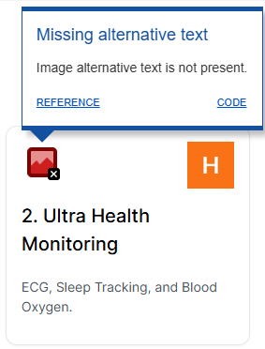 | Each image must have an alt attribute. Without alternative text, the content of an image will not be available to user/ui | Adding an alt attribute can solve this issue | - 1.1.1 Non-text Content (Level A)

Missing form label  (Error) | 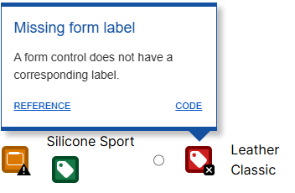 | If form control doesn’t have an associated label,the function or purpose of the control might not be presented to the user end. | Use of <label> element to the function or control. | - 1.1.1 Non-text Content (Level A)  - 1.3.1 Info and Relationships (Level A)  - 2.4.6 Headings and Labels (Level AA)  - 3.3.2 Labels or Instructions (Level A)
Language Missing  (Error) | 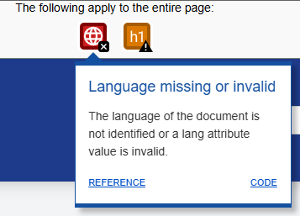 | Language of the page or page elements allows users to read the content in the appropriate language | Using the <html lang> attribute with a valid value(e.g. <html lang=”en”>). | - 3.1.1 Language of Page (Level A)
Empty Button  (Error) | 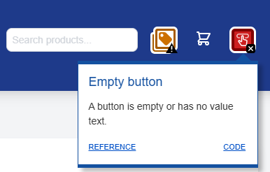 | Description must be presented to screen so the users can indicate the function of the button | By placing text content/icons within <button> element | - 1.1.1 Non-text Content (Level A)  - 2.4.4 Link Purpose (In Context) (Level A)
Empty Link  (Error) | 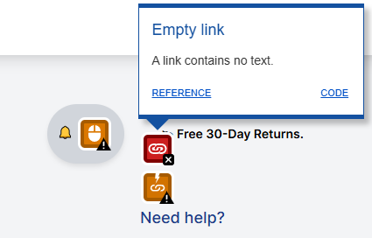 | Link must contain valid link / text as indicator or direction to the user. | Removing empty links or adding descriptive text to indicate the functionality. | - 2.4.4 Link Purpose (In Context) (Level A)
Contrast error  (Error) |  | Adequate contrast of text is a must for all users especially users with low vision. | By increasing the contrast between the foreground /text color and the background color | - 1.4.3 Contrast (Minimum) (Level AA)
Device dependent event handler  (ALERTS) | 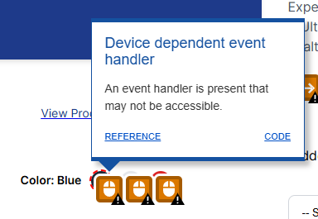 | The JavaScript events in use do not appear to be accessible to both mouse and keyboard users. To be fully accessible, critical JavaScript interaction should be device independent. | Ensure that critical functionality and content is accessible by using a device independent event handler (which responds to both keyboard and mouse) or by using both a mouse dependent and a keyboard dependent event handler. | 2.1.1 Keyboard (Level A)

